Regulations:
A14

H.T No

Sreenidhi Institute of Science and Technology
(An Autonomous Institution)
Code No: 4AC41 Date: 13-Dec-2018 (FN)

B.Tech II-Year I-Semester External Examination, Nov/Dec - 2018 (Supplementary)
Basic Electrical Engineering (ME, CSE and IT)

Time: 3 Hours Max.Marks:70

Note: a) No additional answer sheets will be provided.
b) All sub-parts of a question must be answered at one place only, otherwise it will not be valued.
c) Missing data can be assumed suitably.

Part - A Max.Marks:20

Answer all QUESTIONS.

1. | Explain Kirchhoff’s Voltage Law with an example. | [2M]
2. | Differentiate between statically induced emf and dynamically induced emf. | [2M]
3. | Draw the power flow stages in a DC motor. | [2M]
4. | What is the condition for maximum efficiency in a transformer? | [2M]
5. | What happens if three phase induction motor runs at synchronous speed? | [2M]
6. | What is the expression for the deflection torque in PMMC instrument? | [2M]
7. | What are the various forms of representations of alternating quantities? | [2M]
8. | Explain the significance of Back emf in DC Motor. | [2M]
9. | Differentiate between squirrel cage and slip ring induction motors. | [2M]
10. | What happens if DC supply is given to the transformer ? | [2M]
Part – B Max.Marks:50
ANSWER ANY FIVE QUESTIONS. EACH QUESTION CARRIES 10 MARKS.

11. | a) | Find the current through 10Ωresistance in the given network using superposition  theorem.  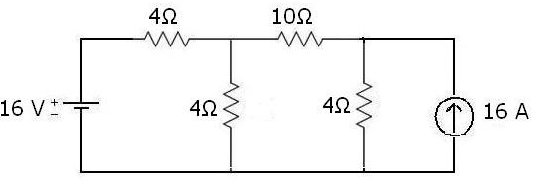 | [7M]
 | b) | Find the equivalent resistance for the circuit shown below.  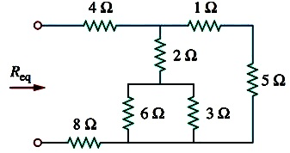 | [3M]
12. | a) | Derive the expression for power consumed in the series RLC circuit. | [5M]
 | b) | A series RL circuit with R=30Ω and L=15H has a constant voltage V=60V applied at t=0 as shown in the fig. Determine the current i, the voltage across resistor and the voltage across the inductor.  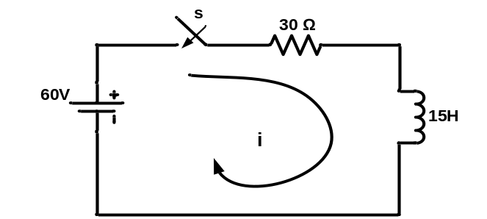 | [5M]
13. | a) | Derive the torque equation of a DC Motor. | [5M]
 | b) | A 220V DC shunt motor runs at 500rpm when the armature current is 50A. Calculate the speed if the torque is doubled. Given that R_{a}=0.2Ω. | [5M]
14. | a) | Explain the construction of transformer with neat sketches. | [5M]
 | b) | A 30KVA, 2400/120V, 50Hz transformer has a high voltage winding resistance of 0.1Ω and a leakage reactance of 0.22Ω. The low voltage winding resistance is 0.035Ω and the leakage resistance is 0.012Ω. Find the equivalent winding resistance, reactance and impedance referred to  (i) high voltage side and (ii) low voltage side. | [5M]
15. | a) | “ The magnetic field produced in a three-phase induction motor is rotating one”.  Explain the statement with necessary proofs. | [7M]
 | b) | Give the relation between line and phase voltage for a three-phase balanced star  connected system. | [3M]
16. |  | With the help of a neat sketch explain the principle of working of a permanent Magnet Moving Coil instrument. | [10M]
17. | a) | Find the current through the 5Ω resistor and the current through the 4V source using Mesh Current Analysis.  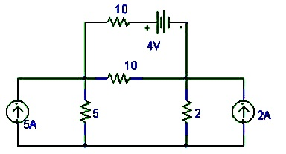 | [6M]
 | b) | For the circuit shown below calculate current through 12Ω resistor using nodal analysis.  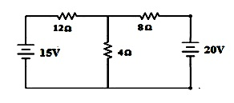 | [4M]
18. | a) | Explain the concept of a practical transformer on no-load and loaded conditions with the help of phasors. | [6M]
 | b) | Why does the rotor of three phase induction motor rotate? Explain. | [4M]
-- 00 -- 00 –

